Top 5 outdoor wedding venues in Miami

When organizing a wedding, we have to make multiple choices. Every step that we take helps us have the perfect wedding, the one that we have been dreaming of all our lives. The most important decisions to be made are venues, photographer, music, food and decorations; we cannot have a wedding without all these things. Many couples choose as a wedding venue a restaurant, or a mansion, or a hall, which are indoor venues. It is nice to have a wedding like that, but why don’t you want to be different? Having a wedding somewhere outdoor can be more exciting, and the memories can be even better, of course, if you combine all those things that matter! Imagine a perfect wedding which takes place on a beach, on a plantation or in an ancient monastery: it is unique and it describes our personality even better than a wedding in a restaurant does. Sometimes, making a choice can be difficult: we have so many services, and so little time to google information about all of them. Because when we prepare a wedding there is no time to do research, there are blogs focused on weddings. This article aims to show us a top of five outdoor weddings in Miami, ranked by users’ reviews.

5. Redland Koi Gardens is a wonderful choice if you want to have an outdoor wedding. The setting is perfect for the people who want to have an intimate wedding, and to feel like they are in a place where tranquility reigns. The landscape is refreshing and natural, and makes you feel serene. Its Koi ponds and its flourishing garden makes this venue ideal for the ones who want a romantic, intimate fairytale. This venue is also ideal for the ones who fell in love with Japanese gardens, because it replicates some of the finest gardens, by its design.

Website: https://www.redlandkoigardens.com/
Pricing: it is private, and you have to contact the owners in order to find it out
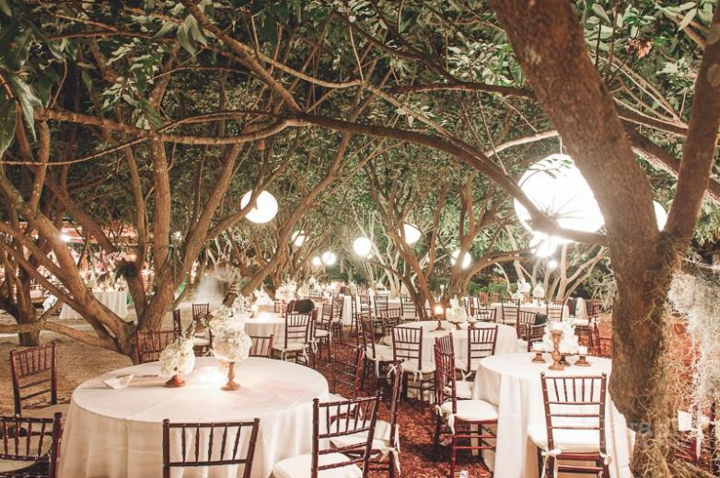

4. Sunset Cove by Imagine. What can be more romantic than a wedding where the sunset is seen live, and you can also see the serene ocean? Of course, nothing beats this landscape. If you are a romantic person, and want your wedding to match your style, this is the perfect venue! If you are not convinced yet, maybe you should know that Sunset Cove is called "Miami's best kept secret" and why PartySpace called it one of the "6 Top Miami Waterfront Wedding Venues". Have you ever dreamed of dancing your wedding dance under the stars? If you choose this venue, you will fulfill your dream, and you will feel literally like a princess or a prince!

Website: https://sunsetcovebyimagine.com/
Pricing: it is private, and you have to contact the owners in order to find it out

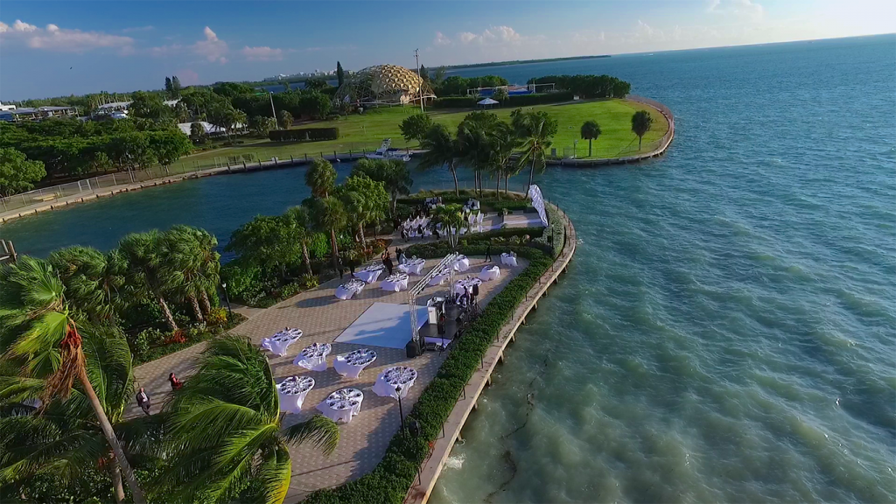

3. The Miller Plantation. Have you ever read Gone with the Wind by Margaret Mitchell, and imagined yourself as Scarlett O’Hara living at Tara? If you have, you know that a plantation is one of the main elements of the background. Have you ever felt that you belong to Colonial Era? If yes, this is the perfect outdoor venue for your wedding. Miller Plantation is located in Coral Gables; it is an oasis situated on five acres. The design reminds you of the 40s colonial style, including elements as if a great waterfall, a meditation garden, koi ponds and even a beach area. The fruit trees & exotic gardens give this venue a touch of natural, of freedom.

Website: http://www.millerplantation.com/
Pricing: it is private, and you have to contact the owners in order to find it out
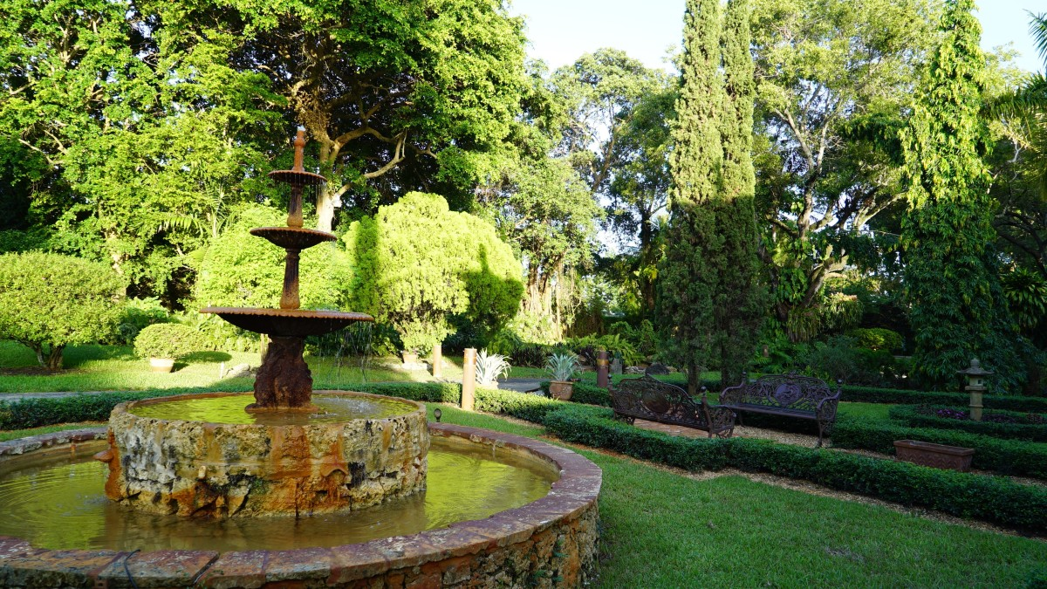

2. The Curtiss Mansion. Who has not heard about Glenn Hammond Curtiss, the aviation legend, also called “The Father of Aviation”? This amazing location, built in 1925, belonged to him and his wife, Lena. Because the old things are always appreciated, it was recently restored to its original glory, and has been listed on the National Register of Historic Places. If you are passionate about local history, why wouldn’t you choose like a wedding venue? With distinctive architectural details, a rich history and tropical landscaping, it is the perfect setting for any engaged couple looking for an unforgettable and experience. Multiple spaces are available for both large and intimate indoor, outdoor and courtyard receptions and ceremonies, which can be held in front of a romantic bridge or under the elegant stone archway.
Website: https://curtissmansion.com/
Pricing: it is private, and you have to contact the owners in order to find it out

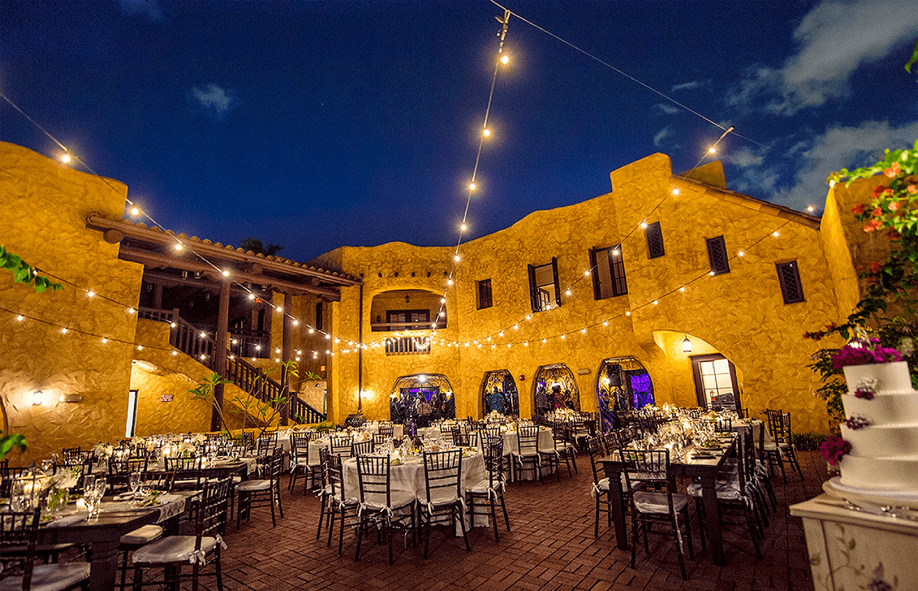

1.The Spanish Monastery is a perfect wedding venue for the romantic ones, for the ones who want a unique, memorable wedding service with beauty, warmth and grace. If you choose this wedding venue, your ceremony and reception can be held both inside the ancient monastery and outside, in its gardens. This venue is perfect for the engaged couples who love history; its ancient design makes it an intimate, romantic place for the most romantic weddings.

Website: http://www.spanishmonastery.com/
Pricing: it is private, and you have to contact the owners in order to find it out

